Classic Voice Instructions
THIS IS A BETA TEST
PLEASE USE THE FORUMS FOR ALL SUPPORT QUESTIONS DO NOT CALL TECH SUPPORT WITH VOICE QUESTIONS
NOTICE: All Microsoft .NET Framework updates must be up to date for this process to work. Click on the link below for more information. This is a site outside of Midnite Solar and subject to change.
https://www.microsoft.com/en-us/download/details.aspx?id=48130

The update is a 3-part. procedure.
Please use the following links for downloading the needed updates
http://midniteftp.com/firmware/voiceloader/MNGPVoiceFileLoader-win32-x64.zip
http://midniteftp.com/firmware/voiceloader/install2151.zip
- Update the Classic itself to make it ready for the Voice download file.
See the documents below for instructions via operating system
- Update the MNGP to ready it for the voice files and add menus for voice.
See the documents below for instructions via operating system
3. Download the voice/sound files into the MNGP. Instructions below the linked documents
Windows 10 update instructions
Windows 7 update instructions

Recovery of a bricked MNGP
Rerun the MNGP update, and do a VMM and it will come back.
What is a VMM?
It has become industry slang for our factory restore ―Vulcan Mind Meld from the 2 fingers needed to push the arrows. Shut the power off to the Classic, hold down the right and left arrows, while holding these buttons down, power up the Classic.

Installation of Voice:
Once you have completed the 2149-2151 updater you are ready to install the Voice/Sound files on your Classic.
Set up your Classic to DHCP Main Menu> scroll to the right using the upper right rectangle key this will highlight NET and press ENTER> Choose DHCP hit ENTER and save changes.
Plug the Classic’s Ethernet Cord in to the Data port on the Classic. The other end should go to a router that is connected to your PC. Direct connect is not recommended.
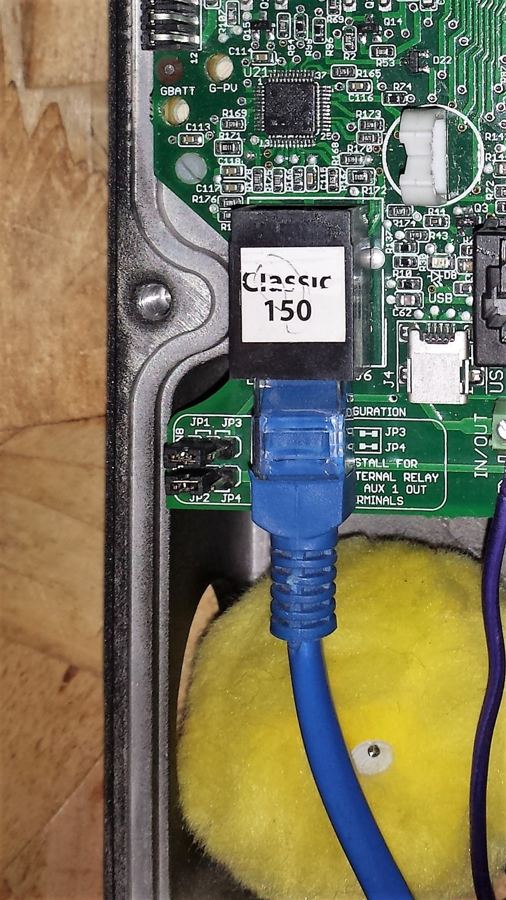

Open the MNGPVoiceFileLoader-win32-x64 folder
Locate the MNGPVoiceFileLoader.exe file and double click on it. This will open the Voice Loader Tool.
Verify that auto detect is checked and that the IP address matches the Classics IP address.
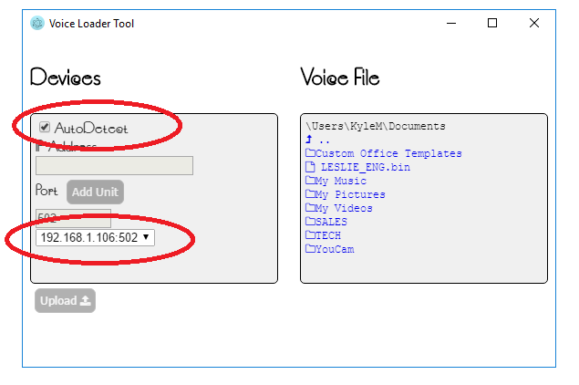
On the right-hand side click on” Leslie_Eng.bin” link. You will need to make sure you are in the correct directory to find the file. It is in the same folder with the Voice tool EXE file.
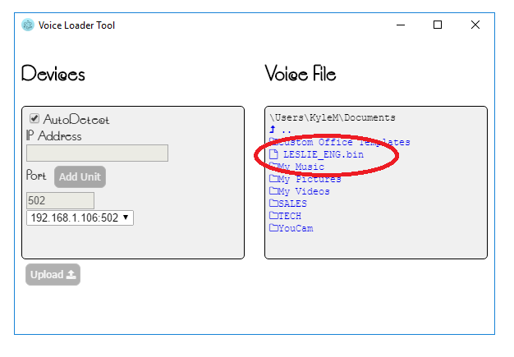

The upload button in the lower left will activate.
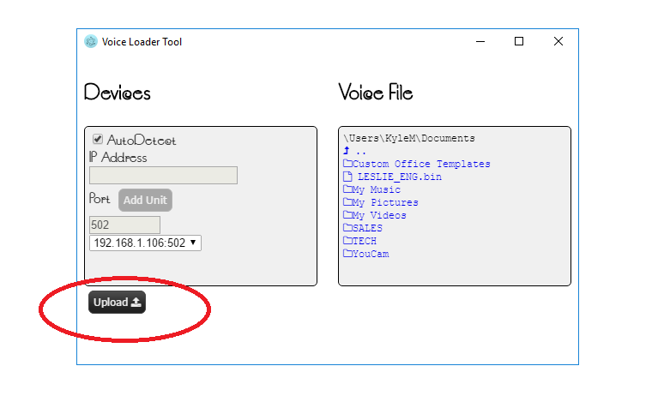

Click on upload and wait. This is a long download; current average time is 150 minutes.
There is a file inside the install2151 folder called “test_voice.bin” which is a much smaller voice/sound file that can be used for testing. It only takes a few minutes to load.
After loading “test_voice.bin” Go to Main Menu > MISC> AUDIO>TEST > keypad presses are as follows:
Enter – Plays all sound samples
Left - Play the first 15 samples
Right – says one
Up - Count test Up
Down - Count Test Down

If the update appears to be successful but no voice is heard, check to be sure your MNGP speaker is plugged in.

